1. Difference between http1.1 and http2- <https://gayathricheedella77217.medium.com/difference-between-http1-1-and-http2-4d07a875f3a>
2. What happens when we type URL in address bar?- <https://gayathricheedella77217.medium.com/what-happens-i-type-url-in-the-address-bar-a4bc7ca15804>
3. Copy by value for composite datatypes- <https://gayathricheedella77217.medium.com/how-do-you-copy-by-value-a-composite-data-type-681bcc187c84>

**why there is a difference in behavior for copying contents in primitive and non primitive type?**

In primitive datatype the variable is created with value it stores in the memory within the datatype bytes. And the length of this primitive datatype is fixed**.** So, in this we use only copy by value.

Whereas In the non-primitive are objects the length of this objects changes dynamically. This values are stored by reference .if we reassign the one object to another object it generally does not allocate new memory it refers to old memory. In default it uses copy by reference

**Write a blog about objects and its internal representation in Javascript?**

Objects are composite datatypes in javascript. These are used in real word for storing huge data. These are based on key-value pair.

Objects written as name value pairs are similar to:

* Associative arrays in PHP
* Dictionaries in Python
* Hash tables in C
* Hash maps in Java
* Hashes in Ruby and Perl

The objects in javascript store values by reference means it does not really store it just points to memory location.

For example:

var student = {name:”rakesh” , age: 13, gender:’M’};

In this name, age, gender are keys where rakesh, 13, M are values.

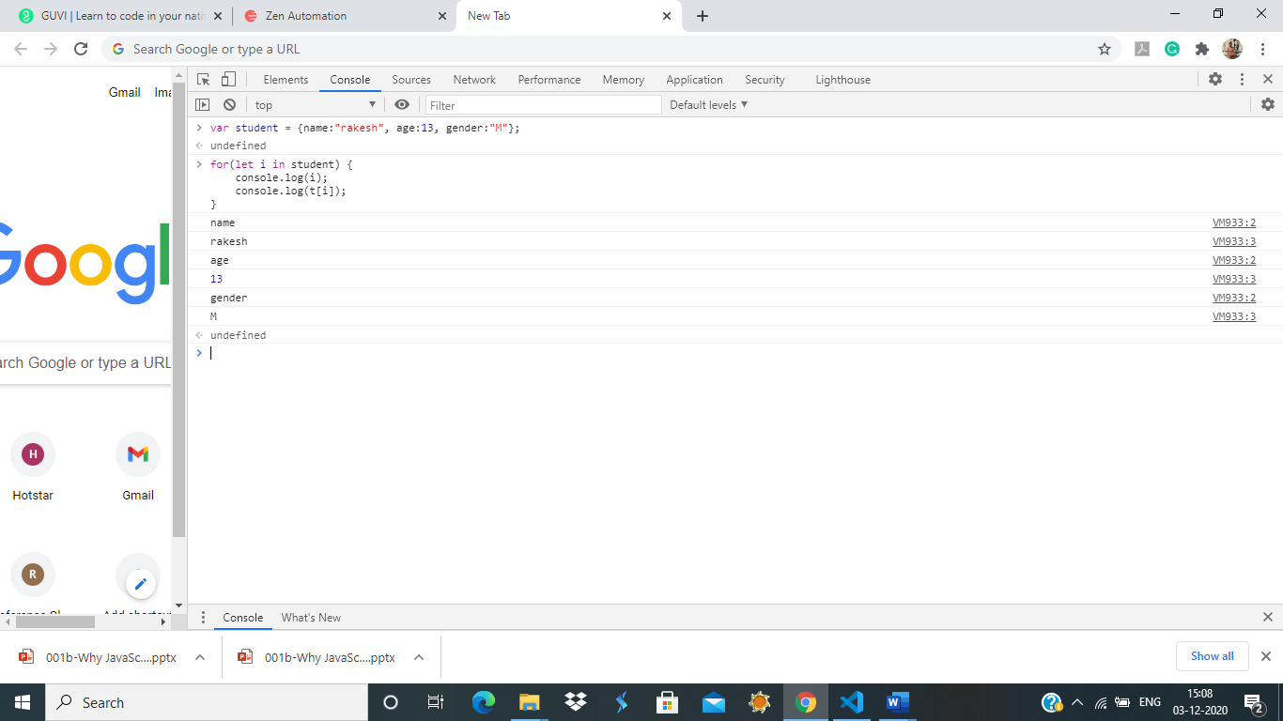

**What is the difference between window, screen, and document in Javascript? - publish as a blog in medium.**

**Window:**

The JavaScript window object sits at the top of the JavaScript Object hierarchy and represents the browser window. The window object is supported by all browsers. All global JavaScript objects , functions, and variables automatically become members of the window object. The window is the first thing that gets loaded into the browser.

**Document:**

Every window object has one document object in it.The Document interface represents any web page loaded in the browser and serves as an entry point into the web page's content, which is the DOM tree. When an HTML document is loaded into a web browser , it becomes a document object. It is the root node of the HTML document. The document actually gets loaded inside the window object and has properties available to it like title, URL, cookie, etc. HTML documents, served with the "html" content type, also implement the HTMLDocument interface.

**Screen:**

The window object also has a screen object with properties describing the physical display:

* screen properties width and height are the full screen
* screen properties availWidth and availHeight omit the toolbar